# Custom Domain Mapping in Microsoft Azure

This article shows you how to manually map a custom domain name to your web app, mobile app backend, or API app in Azure App Service.

Note

You can always just buy a custom domain name directly from Azure.

There are three main steps to map the custom domain to your app:

1. *(A record only)* Get app's IP address.
2. Create the DNS records that map your domain to your app.
   * **Where**: your domain registrar's own management tool (e.g. Azure DNS, GoDaddy, etc.).
   * **Why**: so your domain registrar knows to resolves the desired custom domain to your Azure app.
3. Enable the custom domain name for your Azure app.
   * **Where**: the Azure portal.
   * **Why**: so your app knows to respond to requests made to the custom domain name.
4. Verify DNS propagation.

Types of domains you can map

Azure App Service lets you map the following categories of custom domains to your app.

* **Root domain** - the domain name that you reserved with the domain registrar (represented by the @ host record, typically). For example, **contoso.com**.
* **Subdomain** - any domain that's under your root domain. For example, **www.contoso.com** (represented by the www host record). You can map different subdomains of the same root domain to different apps in Azure.
* **Wildcard domain** - any subdomain whose leftmost DNS label is * (e.g. host records * and *.blogs). For example, **\*.contoso.com**.

Types of DNS records you can use

Depending on your need, you can use two different types of standard DNS records to map your custom domain:

* [A](https://en.wikipedia.org/wiki/List_of_DNS_record_types#A) - maps your custom domain name to the Azure app's virtual IP address directly.
* CNAME - maps your custom domain name to your app's Azure domain name,**<*appname*>.azurewebsites.net**.

The advantage of CNAME is that it persists across IP address changes. If you delete and recreate your app, or change from a higher pricing tier back to the **Shared** tier, your app's virtual IP address may change. Through such a change, a CNAME record is still valid, whereas an A record requires an update.

The tutorial shows you steps for using the A record and also for using the CNAME record.

Important

Do not create a CNAME record for your root domain (i.e. the "root record"). For more information, see [Why can't a CNAME record be used at the root domain](http://serverfault.com/questions/613829/why-cant-a-cname-record-be-used-at-the-apex-aka-root-of-a-domain). To map a root domain to your Azure app, use an A record instead.

Step 1. *(A record only)* Get app's IP address

To map a custom domain name using an A record, you need your Azure app's IP address. If you will map using a CNAME record instead, skip this step and move onto the next section.

1. Log in to the [Azure portal](https://portal.azure.com/).
2. Click **App Services** on the left menu.
3. Click your app, then click **Custom domains**.
4. Take note of the IP address above Hostnames section..

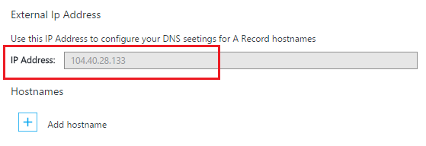

1. Keep this portal blade open. You will come back to it once you create the DNS records.

Step 2. Create the DNS record(s)

Log in to your domain registrar and use their tool to add an A record or CNAME record. Every registrar’s UI is slightly different, so you should consult your provider's documentation. However, here are some general guidelines.

1. Find the page for managing DNS records. Look for links or areas of the site labeled **Domain Name**, **DNS**, or **Name Server Management**. Often, you can find the link by viewing your account information, and then looking for a link such as **My domains**.
2. Look for a link that lets you add or edit DNS records. This might be a **Zone file** or **DNS Records** link, or an **Advanced** configuration link.
3. Create the record and save your changes.
   * Instructions for an A record are here.
   * Instructions for a CNAME record are here.

Create an A record

To use an A record to map to your Azure app's IP address, you actually need to create both an A record and a TXT record. The A record is for the DNS resolution itself, and the TXT record is for Azure to verify that you own the custom domain name.

Configure your A record as follows (@ typically represents the root domain):

|  |  |  |
| --- | --- | --- |
| FQDN example | A Host | A Value |
| contoso.com (root) | @ | IP address from Step 1 |
| www.contoso.com (sub) | www | IP address from Step 1 |
| *.contoso.com (wildcard) | * | IP address from Step 1 |

Your additional TXT record takes on the convention that maps from <*subdomain*>.<*rootdomain*> to <*appname*>.azurewebsites.net. Configure your TXT record as follows:

|  |  |  |
| --- | --- | --- |
| FQDN example | TXT Host | TXT Value |
| contoso.com (root) | @ | <*appname*>.azurewebsites.net |
| www.contoso.com (sub) | www | <*appname*>.azurewebsites.net |
| *.contoso.com (wildcard) | * | <*appname*>.azurewebsites.net |

Create a CNAME record

If you use a CNAME record to map to your Azure app's default domain name, you don't need an additional TXT record like you do with an A record.

Important

Do not create a CNAME record for your root domain (i.e. the "root record"). For more information, see Why can't a CNAME record be used at the root domain. To map a root domain to your Azure app, use an A record instead.

Configure your CNAME record as follows (@ typically represents the root domain):

|  |  |  |
| --- | --- | --- |
| FQDN example | CNAME Host | CNAME Value |
| www.contoso.com (sub) | www | <*appname*>.azurewebsites.net |
| *.contoso.com (wildcard) | * | <*appname*>.azurewebsites.net |

Step 3. Enable the custom domain name for your app

Back in the **Custom Domains** blade in the Azure portal (see Step 1), you need to add the fully-qualified domain name (FQDN) of your custom domain to the list.

1. If you haven't done so, log in to the Azure portal.
2. In the Azure portal, click **App Services** on the left menu.
3. Click your app, then click **Custom domains** > **Add hostname**.
4. Add the FQDN of your custom domain to the list (e.g. **www.contoso.com**).

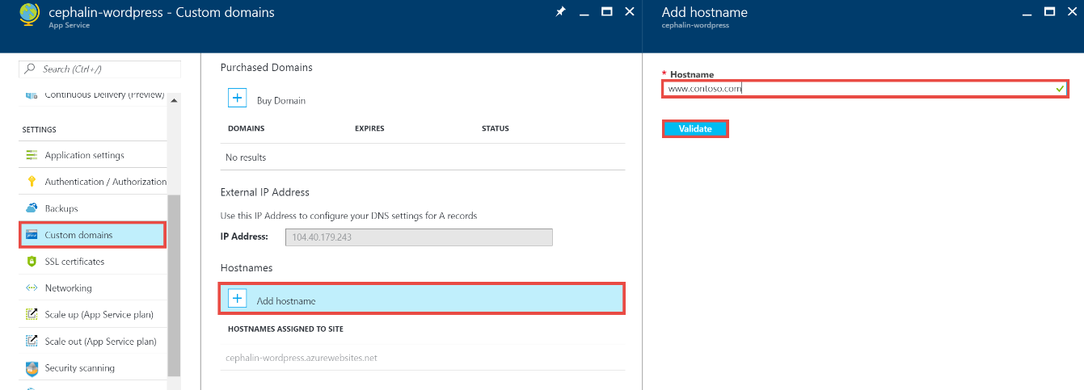

Note

Azure will attempt to verify the domain name that you use here. Be sure that it is the same domain name for which you created a DNS record in Step 2.

1. Click **Validate**.
2. Upon clicking **Validate** Azure will kick off Domain Verification workflow. This will check for Domain ownership as well as Hostname availability and report success or detailed error with prescriptive guidence on how to fix the error.
3. Upon successful validation **Add hostname** button will become active and you will be able to the assign hostname.
4. Once Azure finishes configuring your new custom domain name, navigate to your custom domain name in a browser. The browser should open your Azure app, which means that your custom domain name is configured properly.

Migrate an active domain name

If the domain name you want to map is already in use by an existing website, and you want to avoid downtime, see Migrate an active custom domain to App Service.

Verify DNS propagation

After you finish the configuration steps, it can take some time for the changes to propagate, depending on your DNS provider. You can verify that the DNS propagation is working as expected by using http://digwebinterface.com/. After you browse to the site, specify the hostnames in the textbox and click **Dig**. Verify the results to confirm if the recent changes have taken effect.

